Lab Report 2

*Name: Sricharan Vinoth Kumar*

*Roll no: 2024112022*

*Group no: 10*

Experiment 1:

* Objective:

To analyse and find out the logic function of the given ICs using circuits.

* Electronics Components Used:
  + Digital Test Kit
  + AND, OR, NAND, NOR, XOR ICs
  + Wires
* Reference Circuit:

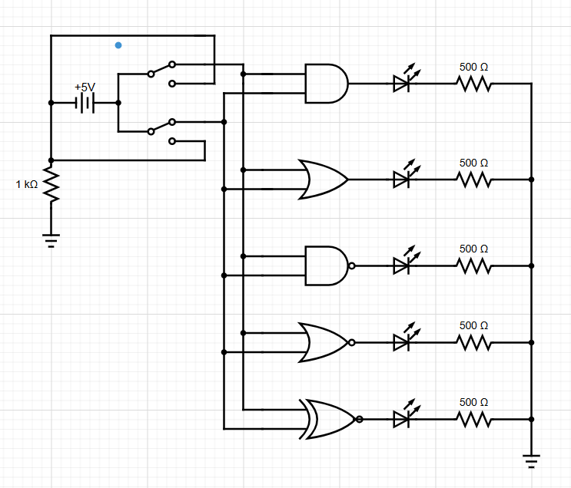

Demo: <https://youtu.be/o05Yn0u40zI>

* Procedure:
  1. Ensure that the CLOCK of the kit is in FAST position and turn the VCC supply on.
  2. Verify the working of the input pins IP1-1P12 and the output LEDs LR1-LR8 and LG1-LG8, by connecting them with the wires given.
  3. Attach one of the given ICs across the centre line of the breadboard.
  4. Connect the VCC and GND pins of the IC to the VCC and GND pins of the kit.
  5. Connect 2 of the available input switches to the input pins of the IC and the corresponding output pin to one of the output LEDs of the kit.
  6. Obtain the truth table of the given IC by taking different combinations of the inputs.
  7. With the obtained truth table, identify the type of logic function.
  8. Repeat Steps 3-7 for all the other ICs.
* Observation:

IC No: 4011 (NAND)

|  |  |  |
| --- | --- | --- |
| **X** | **Y** | **O** |
| 0 | 0 | 1 |
| 0 | 1 | 1 |
| 1 | 0 | 1 |
| 1 | 1 | 0 |

IC No: 7432 (OR)

|  |  |  |
| --- | --- | --- |
| **X** | **Y** | **O** |
| 0 | 0 | 0 |
| 0 | 1 | 1 |
| 1 | 0 | 1 |
| 1 | 1 | 1 |

IC No: 7400 (NAND)

|  |  |  |
| --- | --- | --- |
| **X** | **Y** | **O** |
| 0 | 0 | 1 |
| 0 | 1 | 1 |
| 1 | 0 | 1 |
| 1 | 1 | 0 |

IC No: 4001 (NOR)

|  |  |  |
| --- | --- | --- |
| **X** | **Y** | **O** |
| 0 | 0 | 1 |
| 0 | 1 | 0 |
| 1 | 0 | 0 |
| 1 | 1 | 0 |

IC No: 7486 (XOR)

|  |  |  |
| --- | --- | --- |
| **X** | **Y** | **O** |
| 0 | 0 | 0 |
| 0 | 1 | 1 |
| 1 | 0 | 1 |
| 1 | 1 | 0 |

IC No: 7408 (AND)

|  |  |  |
| --- | --- | --- |
| **X** | **Y** | **O** |
| 0 | 0 | 0 |
| 0 | 1 | 0 |
| 1 | 0 | 0 |
| 1 | 1 | 1 |

* Conclusion:

The given ICs’ logic function has been identified.

* Tinkercad Simulation:

<https://www.tinkercad.com/things/7jsEQt1s2dc-dsm-lab-2-exp-1?sharecode=Dlj4ooGgWFL26uDU7nXF0YMuWwySFDiJPv65pf3Kmt4>

Experiment 2:

* Objective:

To prove using circuitry, De-Morgan’s Theorems.

* Electronic Components Used:
  + Digital Test Kit
  + NAND, AND, NOR, OR ICs
  + Wires
* Reference Circuit:
  + Equation 1:

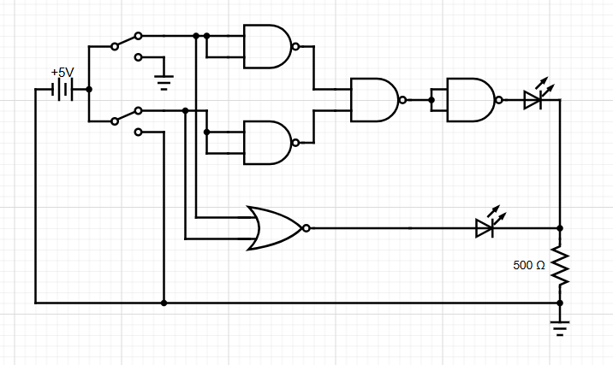

* + Equation 2:

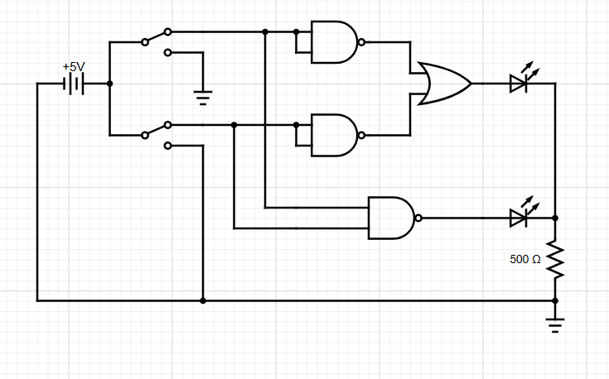

Demo: <https://youtu.be/ppOt_ryA7jM>

* Procedure:
  + Ensure that the CLOCK of the kit is in FAST position and turn the VCC supply on.
  + Verify the working of the input pins IP1-1P12 and the output LEDs LR1-LR8 and LG1-LG8, by connecting them with the wires given.
  + Set up a circuit using 2 NAND gates and one AND gate to represent the function y = A’ . B’. Use a NAND gate as a NOT gate with its 2 inputs connected together.
  + Obtain a truth table of the given circuit and verify that it is the same as that of the NOR gate.
  + Repeat Step 3 using an OR gate instead of AND to represent the function y = A’ + B’. Verify that the truth table of the circuit is the same as that of the NAND gate.
* Observation:

y = A’.B’

|  |  |  |
| --- | --- | --- |
| **X** | **Y** | **O** |
| 0 | 0 | 1 |
| 0 | 1 | 0 |
| 1 | 0 | 0 |
| 1 | 1 | 0 |

The above table is the same as that of the NOR gate.

y = A’ + B’

|  |  |  |
| --- | --- | --- |
| **X** | **Y** | **O** |
| 0 | 0 | 1 |
| 0 | 1 | 1 |
| 1 | 0 | 1 |
| 1 | 1 | 0 |

The above table is same as that of the NAND gate.

* Conclusion:

De-Morgan’s theorems have been verified.

* Tinkercad Simulation:

<https://www.tinkercad.com/things/5y4STdrVRcN-dsm-lab-2-exp-2?sharecode=VtVMZlO-8zz6QsuK6yBJKccaslbKLcx9sKXzUWCY8WI>